Andrews’ Endowed Church of England Primary School  SPECIAL EDUCATIONAL NEEDS AND DISABILITIES (SEND) INFORMATION REPORT  Policy Reviewed: November 2025 | 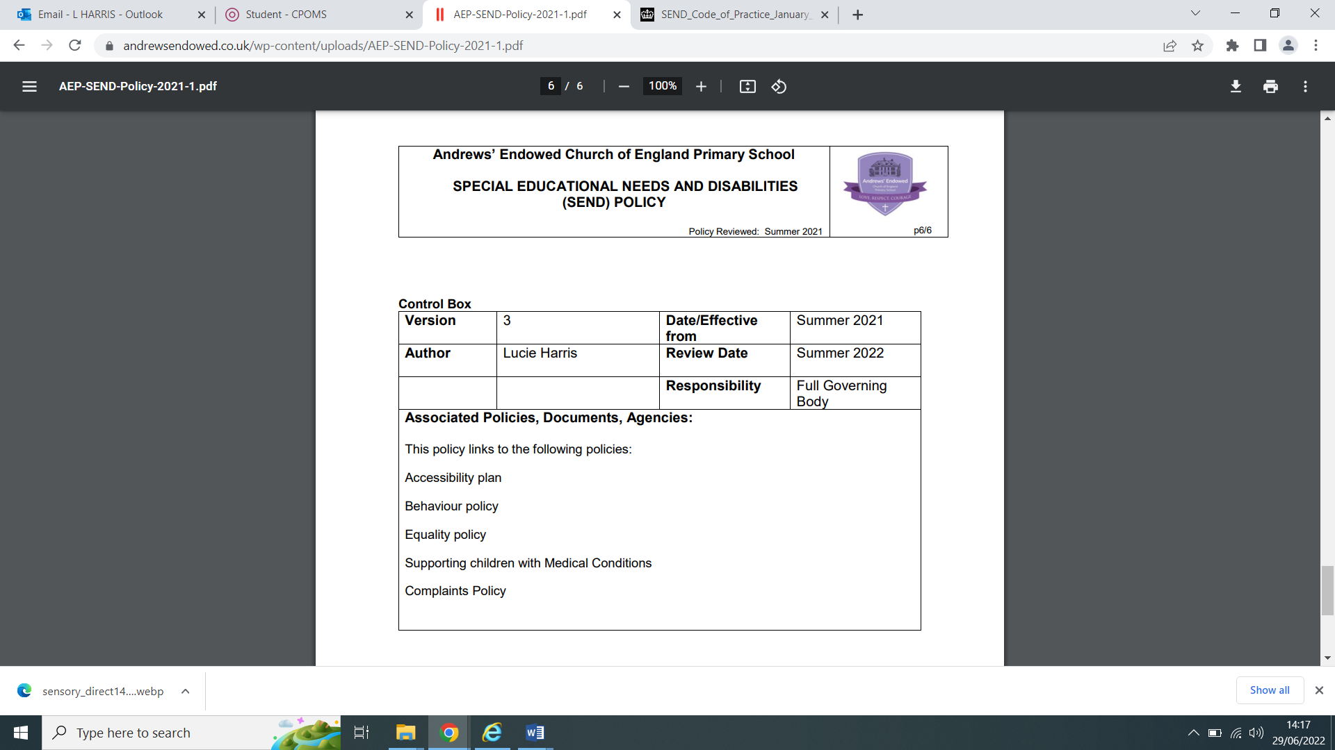
High Aspirations, Moral Strength, Spiritual Depth
Introduction
Andrews' Endowed School is a mainstream primary school, providing an inclusive education for children aged 4 to 11. Our school values are Love, Courage and Respect and it is these core values that provide us with a firm foundation for living, loving and learning together.
Every child who comes to Andrews’ Endowed is valued and cared for within a school community that has high aspirations for them now and in their future lives. Andrews’ Endowed CE Primary School is committed to supporting all pupils, including those with Special Educational Needs and Disabilities (SEND). We are committed to providing an appropriate and high quality education for all our children. We believe that all children, including those identified as having SEND, have a common entitlement to be offered a broad and balanced academic and social curriculum which is accessible to them, and to be fully included in all aspects of school life.
Children and Families Act 2014
The Children and Families Act builds on the Government’s commitment to work to improve services for vulnerable children and to support strong families. It aims to ensure that all children and young people can succeed, no matter what their background. The Act supports changes in the systems for adoption, children looked after, family justice and SEND.
KEY CONTACTS
We have a SENCO who is responsible for the co-ordination of provision for children with SEND, and SEND leadership.
SENCO: Mrs. Lora Bowden
Contact: 01420 83094
Email: senco@andrewsendowed.hants.sch.uk
There are other members of staff who you may wish to contact to discuss your child:
- Headteacher Mrs Gemma Gundry
- Your child’s class teacher
- Key Stage 2 Leader Miss Alison Daffey
- Key Stage 1 Leader Mrs Annie Vincent
OUR ASPIRATIONS FOR PUPILS WITH SEND
We aspire for our pupils with SEND to:

- What kinds of Special Educational Needs are provided for at your school?
We value the abilities of all pupils. We recognise that they learn at different rates, and that there are many factors that affect achievement, including ability, maturity and emotional state.
We believe that all pupils have the same entitlement to the whole school curriculum and we are committed to making this accessible to all pupils whatever their needs. We aim to identify these needs as early as possible.

Our SEND policy ensures that high aspirations, early intervention and appropriate support for all our children are in place. We support a range of children with Special Educational Needs across our mainstream school to access the curriculum and to be confident in themselves. Our children’s individual needs are organised into the following areas:
Cognition and Learning | Moderate, severe, or profound learning difficulties  Specific learning difficulties: dyslexia, dyscalculia, dysgraphia, dyspraxia
Communication and Interaction | Speech and language delay  Impairments or disorders  Hearing impairment  Features within the autistic spectrum
Sensory and/or Physical Needs | Sensory and physical difficulties
Social, Mental, and Emotional Health | Withdrawn or isolated behaviour  Disruptive or hyperactive behaviour  Concentration issues

- How does your education setting know if my child needs extra help and what do I do if I think my child has special educational needs?
Class Teachers are responsible for the day to day learning and wellbeing of each pupil. They will notice a child falling behind in their learning or having a difficulty in another aspect of their daily life.
Class Teachers are informally and formally assessing the children on a very regular basis. We use this information to track the progress of each child. As soon as we notice a child may be falling behind, we share this information with other staff, including the SENCO. Crucially, the school monitors for underachievement relative to potential, not just age-related expectations. We explicitly recognise that a child may be high-attaining but still require special educational provision if they are failing to achieve their cognitive potential or if their learning difficulty significantly impacts their social, emotional, or mental health. In these cases, we use the same robust assessment cycle—including observation, conversations with parents/carers, and checks on areas of need—to determine the best way forward.
Our SENCO (Special Educational Needs Co-ordinator) is a member of staff who is responsible for organising and monitoring all the support for children with SEND.
We have a wide range of different types of support that we can provide for children. Once we know that a child may need help, we carry out additional assessments to help us decide on the best way forward. This usually includes:
-Observation of the child, both in class to see them during their learning, and at playtime to see how they socialise
-Conversations with parents/carers to get a full picture from them of how they feel the child is doing at school and at home. The voice of the parents and children is important to us.
-Checks on areas of the child’s need which might include numeracy, reading, writing, speech and language, wellbeing and social interaction.
We value the information we get from parents at their very first meetings with us – Home Visits and Induction Meetings for our children in Early Years (Acorns); and initial conversations with parents when they tour the school looking for places for their children either in Acorns or further up the school.
Sometimes this information comes to us from other sources. For example, preschools will share information as children are joining us in EYFS, and we receive information from the child’s current school when children are preparing to join us further up the school.
We encourage lots of dialogue between parents and school staff – if parents/carers have a concern about their child’s needs, however small, we want you to share it with us, we can then help to investigate whether additional support is needed to help the child. Talk to your child’s class teacher – she might then suggest you have a chat with the SENCO or the Head.
Once we have a clear picture of your child’s needs, we have a wide range of resources in school we can use to support your child. We also have access to a variety of professionals and services linked to the Local Authority. These include Educational Psychologists, Specialist Teacher Advisors, Speech Therapists, Behaviour Specialists, Paediatricians, the School Nurse service and Family Support Workers.
IDENTIFYING SPECIAL EDUCATIONAL NEEDS
Early Intervention:
- Regular assessments by Class Teachers
- Dialogue with parents to gather information
- Checks on numeracy, reading, writing, speech and language, and social interaction
Parental Involvement:
- Home visits, induction meetings, and school tours
- Continuous dialogue with parents to address concerns
- Supporting Your Child's Learning
Communication:
- Regular Welcome Meetings, Parents Evenings, and End-of-Year Reports
- Pupil Passports outlining interventions and strategies
- Various interventions, including Essential Letters and Sounds, Precision Teaching, and Speech and Language Care plans
Tracking Progress:
- School-wide tracking of progress reported to Governors
- Holding the children at the centre of everything we do
- Continual monitoring of the quality and impact of teaching
- Identifying and tracking the progress of children/young people that require support to catch up by implementing careful assessment and intervention where required
- Identification of children requiring SEND support through the Assess, Plan, Do, Review cycle
- Consideration of application for an Education, Health and Care Needs Assessment (EHCNA)
- All children identified as requiring SEND support, or with an Education, Health and Care Plan (EHCP) are on our SEND register

- How will both you and I know how my child is doing and how will you help me to support my child’s learning?
We believe learning is a partnership between school and home. Each year you will be invited to a Welcome Meeting where teachers will talk about the learning for the year ahead and answer any questions you may have.
Homework is an important way of extending the children’s learning. They will bring home things to do which are linked to the activities they are busy with in class – the Home/School Link Book is a useful way to let us know how your child is doing with their home learning.
We encourage informal drop-ins at the end of the school day – class teachers are available on the playground and you can either ask to see the teacher there and then, or organise a short meeting for another day.
Parents Evenings are held in the Autumn and Spring terms, and are an opportunity for class teachers to share with parents the progress their child is making and talk about targets for the coming weeks.
In July you will get a full end of year Report, which summarises your child’s progress and current National Curriculum level. You will also have an opportunity to discuss your child’s report with your child’s teacher if you have any further questions.
Children in Early Years (Acorns) also have Google Classroom which provides a learning journal to record photos, observations and comments, in line with the Early Years Foundation Stage curriculum, to build up a record of your child's experiences during their time with us. You will also receive a weekly newsletter from Acorns which shares the learning the children have been doing and gives some information about the next week’s curriculum.
If we identify that your child needs additional support, we will share this with you and then draw up a pupil passport to address their needs. We use a child friendly format so the children have ownership of it, and can refer to it to support their learning. The passport also contains all the strategies that the adults use in class to support the child with their learning.
The Assess, Plan, Do, Review Cycle:
For children on our SEND register, an Assess, Plan, Do, Review cycle was established by class teachers in partnership with the children and their parents.
During the 2025/26 academic year, we have 32 children receiving SEN Support of which 11 children have an Education ,Health and Care Plan.
This year, our class teachers use Ordinarily Available Provision as well as the following provision made for children on our SEND register has been:

We monitor the quality of this provision through learning walks and observations. We measure the impact of this provision through analysis of our provision management system, which tracks interventions across the school, and through discussions with children.
- Ongoing monitoring is carried out by class teachers/ Head teacher and SENCO to identify pupils who are not making adequate progress.
- Following further assessments, and after discussions with key staff and parents, additional support may be put into place to help work towards overcoming any difficulties. Any child requiring support or additional interventions which are different from or additional to those provided as part of the school’s usual working then a child will be provided with a Pupil Passport (PP).
- A PP aims to provide a complete picture of that pupil, including their strengths, the support they receive (both from internal and external sources) and targets which reflect the advice offered by the professional.
- This additional support is documented by the school. In consultation with the class teacher, and parents, short term targets as part of the PP, based on the desired outcomes for the child, are agreed which prioritise key areas of learning.
- Where external agencies are involved, their advice and recommendations are included in this planning. Actions agreed take into account each strengths as well as their difficulties. Any child who has a PP in place will be added to the school’s SEND Register; it is removed when the additional support is no longer required.
- In some cases, and for pupils who already have an Education Health and Care Plan (EHCP), learning support assistance may be allocated. The level of support will reflect the complexity of the child’s needs.
- There will be an expectation that pupils should develop independent learning skills, as far as possible, and not become reliant on adult supervision.
- Review meetings are held at least termly via parents’ evenings, pupil passport review meetings or other arranged meetings between SENCO, teacher and parent(s). Parents, pupils and, sometimes, relevant external agencies are invited to these reviews. When a pupil has an EHCP a formal annual review is also undertaken to which relevant external agencies are also invited. The pupil’s views are always presented whenever possible. Reviews consider the impact of any support and intervention, along with the progress towards targets set. Support arrangements and targets are updated and revised accordingly. If not involved already, this might include referral to external agencies. The outcomes of these meetings are formally recorded
- When the advice of an external agency is sought, the parents are included in the initial assessment process which normally involves a meeting between a parent and the professional. After the child has been assessed, feedback is usually provided in the form of a written report and /or a follow up
meeting. The child’s views are always considered either through a direct observation or a discussion, dependant on age and ability
Currently, assessments we use to decide which Interventions we need include:
- DEST (EYFS screening for Dyslexia) and DST (Y2+ re-screening programme)
- White Rose Maths Assessment (KS1 and KS2)
- SNAP Analysis
- Salford Reading Tests
- Vernon Spelling, SWST Spelling Test
- Essential Letters and Sounds Phonics assessments
How will my child be involved in decisions made about their education?
The level of involvement will depend on your child’s age and level of competence. We recognise that no 2 children are the same, so we will decide on a case-by-case basis, with your input.
We may seek your child’s views by asking them to:
  - Attend meetings to discuss their progress and outcomes
  - Prepare a presentation, written statement, video, drawing, etc.
  - Discuss their views with a member of staff who can act as a representative during the meeting
  - Complete a survey

- How will the school staff support my child?

Within any class, there will be a range of abilities and maturities. The class teachers are experienced in amending the curriculum to the needs of each child, and grouping the children so that they can best access their learning. Schools call this process amendments and Ordinarily Available Provision. It may mean that your child is completing the work in a different way for maths, literacy, spelling, or reading and that he or she sometimes works in a large group, sometimes in a small group with an adult, or sometimes even on a 1:1 basis.

Learning is supported in the classroom by the class teacher and the teaching assistant. Much of your child’s learning will take place in their classroom, but sometimes learning takes place in one of our group learning rooms or areas. These are set up to support small groups and individualised learning through the materials they have on offer, or the space available, or the opportunity to work with different members of staff, or children in different classes.

Our support staff team is led by our SENCO. We have a number of Teaching Assistants who work with the children both in the classroom and in delivering interventions. All our staff receive regular training in all aspects of learning, including provision for children with special educational needs. Class teachers and Support staff who deliver interventions have been trained in using these materials, and are supported by the SENCO in their day-to-day delivery. The team includes those trained specifically to support children’s emotional wellbeing (called ELSAs) and their speech and language development, as well as their numeracy and literacy.

- How will the curriculum at your school be matched to my child’s needs?

We believe that a good classroom environment is one which supports the learning needs of all children. Well organised resources which the children can access independently, clear visual prompts to help the child know what is happening, (such as a visual timetable of the day), and routines to help the children organise themselves and their learning are all important features in all our classrooms. Our learning environments also take into consideration the sensory needs of children.

The curriculum is adapted to meet the needs of each child through amendments and through the use of Ordinarily Available Provision. Interventions are used to support children’s learning and help them access the curriculum at their level.

For a very small number of children, usually those on an EHCP (Education and Health Care Plan) more significant adaptations might be needed. This might include adapting the curriculum where a child’s learning needs are significantly different from the rest of the group.

The Core of Our Support: Ordinary Available Provision (OAP)
The curriculum is adapted to meet the needs of each child through amendments and through the use of Ordinarily Available Provision. This provision is the Quality First Teaching (QFT) delivered by all class teachers. It ensures all pupils can access the broad and balanced curriculum.OAP means that your child may be completing the work in a different way for subjects like maths, literacy, spelling, or reading, and that they sometimes work in various groupings (large, small, or 1:1). Key elements of OAP in our classrooms include:
- Well-organised resources that children can access independently.
- Clear visual prompts to aid understanding (such as a visual timetable of the day).
- Established routines to help children organise themselves and their learning.
- Consideration of the sensory needs of children within the learning environment.

The aim is that all children develop independent learning skills as far as possible.

Staff Support and Training
An ongoing programme of training is in place to ensure that all teaching staff have appropriate skills and knowledge to support provision for children with SEND. Ongoing training has covered understanding and meeting the needs of children, the Ordinarily Available Provision, phonics teaching, behaviour management and supporting children’s overall wellbeing. In addition, teaching assistants have been trained by the Speech and Language Therapist and individual, one-to-one, teaching assistants receive training relevant to the needs of the pupils they support. Children who present with features of emotionally-based school avoidance (EBSA) are supported in a way that best suits the child and family’s specific needs on a bespoke basis.
Accessible Environment
Full accessibility with disabled toilet and parking
Parental Involvement and Support
Sensory audited environment
Active engagement through regular liaison and informal drop-ins
Parent help in classrooms, outings, and special events
Student involvement in decision-making through School Council and issue boxes
Addressing Concerns
Resolution through dialogue with Class Teacher, SENCO, or Headteacher
Support available through Hampshire SENDIASS
Formal complaints process available as outlined in the school Complaints Policy
Transition Support
Transition programs for new entrants and those moving to secondary school
Taster days, curriculum enrichment experiences, and additional visits for a smooth transition
FURTHER INFORMATION
The Local Offer Each local authority (LA) is required to inform children, young people and parents/carers about the provision available for children and young people with SEND. This will include a variety of services provided by the LA and how to access them. Every school in the LA is also required to provide information about what support is available for children in their care. To clarify this, the Government, aided by parents/carers, have sought to answer the most frequently asked questions.
Local Offer for Hampshire provides information about services
Hampshire SENDIASS offers advice and support (info@hampshiresendiass.co.uk or 0808 164 5504)
Department for Education website for additional resources
This SEN Information Report reflects our commitment to providing the best support for every child at Andrews' Endowed School. Your partnership is crucial in ensuring the success and well-being of our students.

Andrew's Endowed has gone out of their way to put in support for my children in and out of the school. Such kind and caring staff always go above and beyond as much as they can .
Andrews' Endowed CE Primary School has an excellent special needs program, they have supported my daughter with counselling and understanding and making her feel comfortable to discuss her problems. The teachers and headteacher have always been open and clear with communication with supporting my daughter and myself. I see a real difference in my daughter and confidence thanks to the kindness and support of the school and services they have given

