Andrews’ Endowed Church of England Voluntary Aided Primary School


Admission Policy 2025-2026

Policy Determined by the Governing Board – September 2024
This policy will be used during 2025-2026 for allocating places in the main admission round for entry to Year R in September 2025. It will also apply to in-year admissions during 2025/26. Outside the normal admissions round, the Fair Access protocol will be applied alongside the policy to secure the admission of vulnerable pupils from specific groups.
The Governing Board is the admission authority for Andrews’ Endowed Church of England Primary School. The admissions arrangements are determined by the Governing Board after statutory consultations.
Published Admission Number
Each school has a published admission number (PAN) for entry to Year R. The school will admit this number if there are sufficient applications. Where fewer applications than the published number are received, places will be offered to all applicants
The PAN for Andrews’ Endowed Church of England Primary School for 2025-2026 is 30.
The guiding principle of admission to this school is that a church school should serve its local community, defined in the trust deed dated 1719 as the ecclesiastical parish of The Resurrection, Alton.
The Governing board will consider first all those applications received by the published deadline of midnight on Wednesday 15th January 2025. Notifications to parents offering a primary or infant school place will be sent by the Local Authority on Wednesday 16th April 2025.
Applications made after midnight on 15th January 2025 will be considered after all on-time applications have been fully processed unless exceptional circumstances merit consideration alongside on-time applications.
For the normal admission round, all on time preferences will be considered simultaneously and ranked in accordance with the admission criteria. If more than one school can offer a place, the parent’s highest stated available preference will be allocated.
Pupils with an Education, Health and Care Plan (EHCP)
Any child with and Education, Health and Care Plan Andrews’ Endowed Church of England Primary School will be admitted. Where possible such children will be admitted within PAN.
Oversubscription criteria
When the school is oversubscribed, after the admission of pupils with an Education, Health and Care plan naming the school, priority for admission will be given to children in the following order:
- Looked after children or children who were previously looked after (see definition i)

- Children or families with an exceptional medical and/or social need (see definition ii). Each application must include supporting evidence from an independent professional such as a doctor and/or consultant for medical needs or a social worker, health visitor, housing officer, the police or probation officer for social needs. This evidence must confirm the child or family’s medical or social need and why that need(s) makes it essential that the child attends Andrews’ Endowed Church of England School rather than any other. Applicants will only be considered under this criterion if on the application form (online or paper) they have ticked the appropriate box explicitly indicating that they wish for their application to be considered under medical / social need and supporting evidence is submitted with the application.

- Children living in the catchment area (see definition iii) of Andrews’ Endowed Church of England Primary School who at the time of application have a sibling (see definition iv) on the roll of the school who will still be on the roll at the time of admission.

- Children living in the catchment area of Andrews’ Endowed Church of England Primary School.

- Children living out of the catchment area who at the time of application have a sibling (see definition iv) on the roll of the school who will still be on the roll at the time of admission. (Where a sibling was allocated a place at the school in the normal admission round in a previous year because the child was displaced (see definition v) from the catchment school for their address, the application will be considered under criteria 3 above, subject to the siblings still living in the catchment area for the school from which they were displaced.)

- Children living out of catchment area of Andrews’ Endowed Church of England Primary School.
The following faith-based criterion may be included before criteria 6 -
A child or a child with a parent who is an active member of a Christian church as defined by the following statement;
“A worshipping fellowship who confess the Lord Jesus Christ as God and Saviour according to the Bible and therefore seek to fulfil together their common calling to the glory of the one God, Father, Son and Holy Spirit; who are members or participant observers of the World Council of Churches or the World Evangelical Alliance.”
And who requests admission on denominational grounds and provides relevant evidence. (See definition vi)
Tie Breaker
If the school is oversubscribed from within any of the above categories, straight line distance will be used to prioritise applications; applicants living nearer the school have priority. Distances will be measured from the Ordinance Survey home address point to the school address point using the Local Authority’s geographic Information Systems (GIS). Distances to multiple dwellings will give priority to the ground floor over the first floor and so on. On individual floors, distances will be measured to the stairs leading to the communal entrance. Where two or more applicants are equidistant, random allocation will be used to allocate the place. An explanation of the random allocation procedure is available on the Local Authority website.

Additional Information
Who can apply?
Only a parent can apply for a place at a school. A parent is any person who has parental responsibility for or is the legal guardian of the child, as set out in the Children Act 1989.
Permanent residence
The child’s permanent residence is where they live normally, including weekends and during school holidays as well as during the week and should be used for the application. The permanent residence of children who spend part of their week with one parent and part with the other, at different addresses, will be the address at which they spend most of their time. Where a child’s time is evenly divided between the parents, parents must agree which address they would like to be considered for the purposes of the application. In the event of a dispute, in the absence of a relevant court order, the admission authority will make a judgement about which address applies, taking into account the address registered with the child’s current school, nursery, pre-school or child-minder, the address registered for child benefit and the address registered with the child’s GP.

Multiple Births
Where a twin or child from a multiple birth is offered the last place available within the PAN, any further twin or child from the same multiple birth will also be offered a place, if the parents so wish, even though this may raise the number in the year group above the school’s PAN.
Fair Access Placements
Outside the normal admissions round, it may sometimes be necessary for a pupil to be placed by the governing board or the Local Authority, in a particular school even if there is a waiting list for admission. Such placements are made in accordance with the Local Authority’s Fair Access Protocol. The Protocol is based on legislation and government.

Waiting Lists
Waiting lists will be established for each year group where more applications are received than places available.
Any places that become available will be offered to a child at the top of the list on the day the place becomes available. The waiting list is ordered according to the criteria of the admission policy with no account being taken of the length of time on the waiting list or any priority order expressed as part of the main admission round. Fair Access arrangements and school closure arrangements will take priority over the waiting list.
The waiting list will be reviewed and revised –
- Each time a child is added to or removed from, the waiting list;
- When a child’s changed circumstance affects their priority.
For entry to Year R, the waiting list will be maintained by the school until 31 August 2025, at which point all names will be removed. For all other year groups, waiting lists will remain open until 31 August of each year. Should parents wish their child to be considered for a place at the school in the following school year, they must submit a new in-year application in the August preceding the new school year. Schools will send a decision letter within the first 10 days of the new term.
Starting school
Pupils born between 1 September 2020 and 31 August 2021 (inclusive) are entitled to full time schooling from September 2025. Parents can choose to defer their child’s admission until later in the school year (but not beyond the start of the term after the reach compulsory school age). Children can also attend part-time until they reach compulsory school age. Parents must discuss their child’s starting arrangements with the school once an offer has been secured.
Children with birthdays between
- 1 September and 31 December 2020 (inclusive) reach compulsory school age on 31 December 2025, at the start of the spring term 2026.
- 1 January and 31 March 2021 (inclusive) reach compulsory school age on 31 March 2026, at the start of the summer term 2026
- 1 April and 31 August 2021 (inclusive) reach compulsory school age on 31 August 2026, at the start of the new school year in September 2026.
Parents of summer born children (those born between 1 April and 31 August) who are particularly concerned about their child’s readiness for school can request to delay their child’s entry to Year R for an entire school year until September 2026. This is called decelerated admission. In making a request, parents would be expected to state clearly why they felt decelerated admission to Year R was in their child’s best interest. It is recommended that parents considering such a request contact the school in the autumn term 2024 to ensure that an informed decision is made.
Admission of children outside their normal age group
Parents may request that their child is admitted outside of their normal age group. To do so, parents should include a request with their application, specifying why admission outside the normal age group is being requested and to which year group they wish their child to be admitted. Decisions will be made based on the circumstances of the case and in the best interests of the child.
School Closures
In the event of a school closure, pupils from the closing school may be given priority for any school nominated as the receiving school. Specific arrangements will be determined by the school and Local authority in accordance with the School Admission Code and will be published at the time for specific schools affected.
Admission Appeals
If you are unsuccessful in being offered a place for your child at Andrews’ Endowed Church of England Primary School you will be informed by the Local Authority in writing, will be given reasons for the refusal and informed of your right to an independent appeal against the decision.
Warning
Places are withdrawn every year because parents give false information on application forms, e.g. a false home address. This includes cases where parents take out a short term let or buy a property solely to use its address on the application form without any intention of taking up permanent residence there. In fairness to all parents, all allegations of fraudulent practice brought to the Governing Board’s attention will be investigated. The Governing Board reserve the right to withdraw the offer of a place if fraudulent of intentionally misleading information has been used on an application.

How to apply
The Local Authority operates a Co-ordinated Admissions Scheme which processes all main round (ordinary) admissions applications. You must complete a Local Authority Form available from website. www.hants.gov.uk/admissions
Definitions
- Looked after children are defined as those who are a) in the care of a local authority, or b) being provided with accommodation by a local authority under exercise of their social services functions (see definition in section 22(1) of the Children Act 1989). Previously looked after children are those who were looked after but immediately after being looked after became subject to an adoption order, child arrangement order, or special guardianship order; this also includes those children who appear (to the admission authority) to have been in state care outside of England and ceased to be in state care as a result of being adopted. An adoption order is an order under section 46 of the Adoption and Children Act 2002 or section 12 of the Adoption Act 1976. Child arrangement orders are defined in section 8 of the Children Act 1989, as amended by section 12 of the Children and Families Act 2014. Child arrangements orders replace residence orders and any residence order in force prior to 22 April 2014 is deemed to be a child arrangement order. Section 14A of the Children Act 1989 defines a ‘special guardianship order’ as an order appointing one or more individuals to be a child’s special guardian(s).

- ‘Medical need’ does not include common medical conditions supported in mainstream schools, such as asthma or allergies. ‘Social need’ does not include a parent’s wish that a child attends the school because of a child’s aptitude or ability or because their friends attend the school or because of routine childminding arrangements. Priority will be given to those children whose evidence establishes that they have a demonstrable and significant need to attend a particular school. Equally this priority will apply to children whose evidence establishes that a family member’s physical or mental health or social needs mean that they have a demonstrable and significant need to attend a particular school. Evidence must confirm the circumstances of the case and must set out why the child should attend a particular school and why no other school could meet the child’s needs. Providing evidence does not guarantee that a child will be given priority at a particular school and in each case a decision will be made based on the merits of the case and whether the evidence demonstrates that a placement should be made at one school above any other.

- A map of www.hants.gov.uk/admissionscatchment area is available as an appendix.

- Sibling refers to brother or sister, half-brother or half-sister, adoptive brother or adoptive sister, foster brother or foster sister, step-brother of step sister living as one family unit at the same address. It will also be applied to situation where a full, half or adopted brother or sister are living at separate addresses.

- Displaced refers to a child who was refused a place at the catchment school in the normal admission round having named it in the application and was not offered a higher named preference school. To identify the child’s catchment school please use the links below. Note that some addresses are in catchment for more than one school and in this case, displaced refers to a child who was refused a place at any of their catchment schools.

https://www.hants.gov.uk/educationandlearning/findaschool/schooldetails?dfesno=3344

Catchment details can be found online at:
https://www.hants.gov.uk/educationandlearning/findaschool/schooldetails?dfesno=3305
or search for the catchment school using a postcode:
https://www.hants.gov.uk/educationandlearning/findaschool

- Active member of a Christian Church is defined as attending worship at a church under the definition given in this policy at least once a month for the previous two years before the deadline for admissions. Parents applying under this criterion are required to complete a Supplementary Information Form (SIF) which asks for a declaration and verification of the child’s or your active membership. The SIF is available from the school and must be completed and returned to the school by midnight on the 15th January 2025. As it is a paper form that needs to be signed, the SIF is not available online. In order to ensure that you have the required church attendance you may need to complete two or more forms. This is normally more applicable to those who have moved into the area but attended church at their previous address.
In the event that during the period specified for attendance at worship the Christian church has been closed for public worship and has not provided alternative premises for that worship, the requirements of these arrangements in relation to attendance will only apply to the period when the church or alternative premises have been available for public worship.
- Staff includes all those on the payroll of the school who have been an employee continuously for two years at the time of application. Children of staff refers to a situation where the staff member is the natural parent, the legal guardian or a resident step-parent.

Legislation
This policy takes account of all Equalities legislation, together with all relevant regulation and the School Admissions Code (Published by the DfE in 2021)
Contact Details of the School
Andrews’ Endowed Church of England Primary School
92 London Road, Holybourne, Alton, Hampshire GU34 4EL
Tel: 01420 83094 Email: adminoffice@andrewsendowed.hants.sch.uk

APPENDIX 1 - MAP OF THE CATCHMENT AREA OF THE SCHOOL
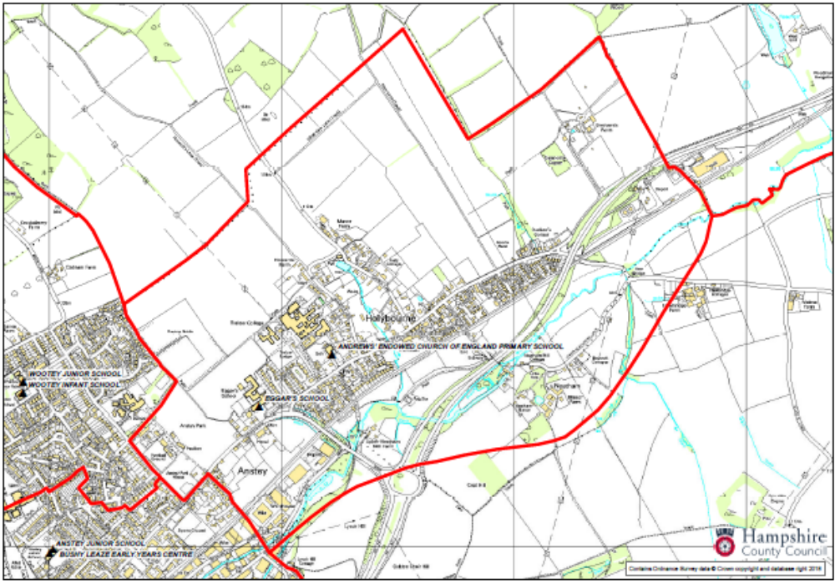

SUPPLEMENTARY INFORMATION FORM
Only use to support admission applications using the
“Active member of a Christian church” criteria

The purpose of this Supplementary Information Form is to verify the active membership of a Christian church of one parent. Active membership is defined as attending worship at a Christian church at least twice a month for the previous two years before the deadline for admissions set by the Local Authority.
You must complete this form, declare your active membership, have it supported by the designated church official and return it to the school as soon as possible but before the deadline for primary school admissions set by the Local Authority. (The designated church official is usually the vicar or minister; please ask at your church or the church school you are applying to who has been designated to validate your declaration.)
If you do not submit this form in time, your application cannot be considered under the faith criterion.
I |  |  |  |  |  |  | Parent Name
Of |  |  |  |  |  |  | Address
Being the Parent of
 | Child’s Name |  |  |  |  |  | Child’s Date of Birth
applying for a place at
declare that my active membership of a Christian church is described as attending worship at a Christian church at least twice a month for at least the previous two years before the deadline for admissions set by the Local Authority.  In the event that during the period specified for attendance at worship the Christian church has been closed for public worship and has not provided alternative premises for that worship, the requirements of these arrangements in relation to attendance will only apply to the period when the church or alternative premises have been available for public worship. |  |  |  |  |  |  |  | _{please tick}
Parental signature |  |  |  | Please print your name
Date: |  |  |  | Date:
PLEASE GET THIS FORM SIGNED BY THE CHURCH OFFICIAL VERIFYING YOUR DECLARATION
I verify that the information regarding attendance at worship given above is correct.
Signature
Please print your name
Name of the Christian Church
Status within the church
(Vicar / Priest in Charge etc)
Date
Contact address and telephone number
For School Use Only
Accepted by the school as a validated “active members of a Christian church” declaration and signed on behalf of the Governing Body by
Name of person signing on behalf of the Governing Board. |  | Name |  |  | Signature | Date
Please return this form to the Church of England School you are applying to as soon as possible before the deadline for school admissions set by the Local Authority.

